**Basic ICANET Users Guide**

* Accessing the ICANET:

You can access the ICANET via the public ICA website ([www.icaworld.net](http://www.icaworld.net)). Log in to the ICANET platform with your personal username and password.

* The “HOME” section:

This page will provide you with general information (about ICA, about individual members…) as well as some useful tools and documents.

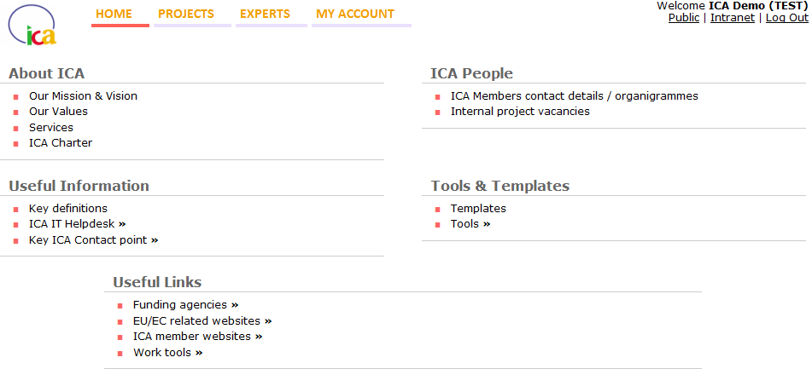

* The “PROJECTS” section:

**1. My Tender Board**

The **“My Tender Board” represents the list of your companies’ projects**: whether they are in the identification stage, in tendering, implementation or closed. You will be able to allocate a specific status to each of your projects – which will then appear as classified in the “My Tender Board” list, according to the status which you allocated to the projects.

A **filter** at the top of the page enables you to view your projects according to one of the 4 following project steps: Active – Implementation – Closed – Inactive.

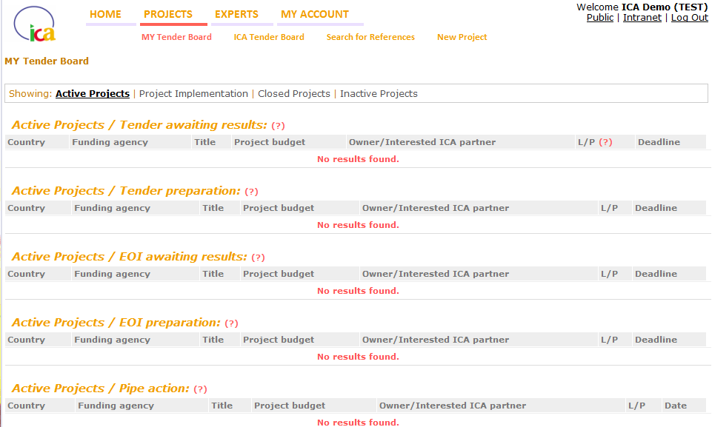

Once you will have created a project in your company’s Tender Board (either by downloading it via Assortis DTA, or by inputting a new projects via the “New Project” tab of the ICANET – see below), you will be able to **access the project information** by clicking on the project title. The **“Edit Project” sheet** as shown below will appear.

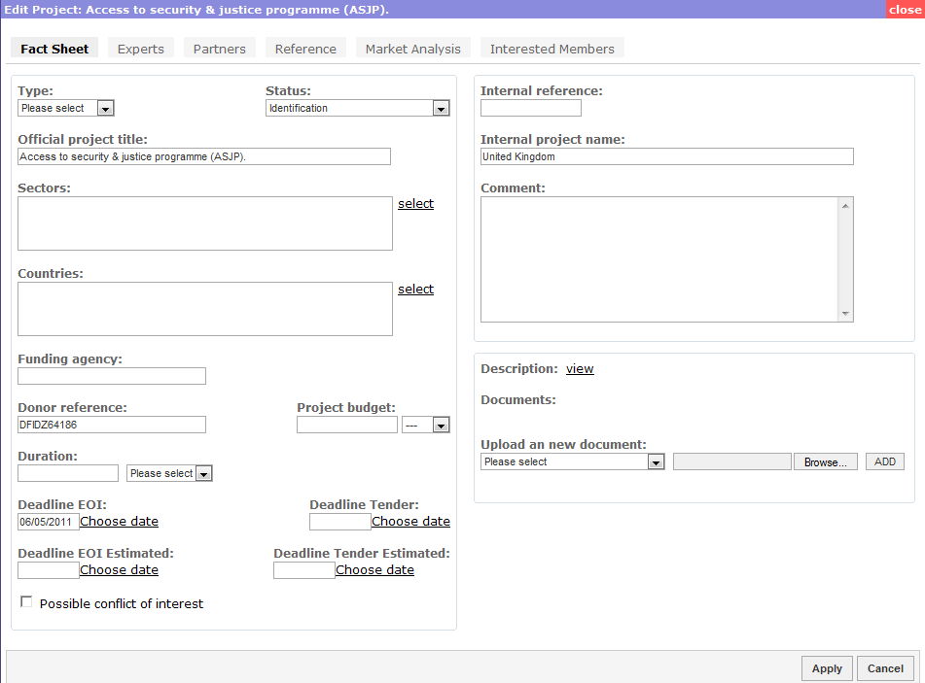

This sheet is essentially what enables you to manage your projects, i.e. change / update any information related to the project.

The tabs on top of the Project Edit sheet enable you to view and manage the following items:

* Access *general information* about the projects (“**Fact Sheet**” tab)
* Publish related *project vacancies* on the public ICA website (“**Experts**” tab)
* List and keep track of the *partners* you would like to work with on this project (“**Partners**” tab)
* List the *references* you would like to submit for this project (“**Reference**” tab)
* View any *market information,* i.e. whether any other projects are or have taken place in the same country (“**Market Analysis**” tab). More data is to come here in the future (“version 2” of the ICANET)
* View what other ICA members are also interested in the same project as you are (“**Interested Members**” tab)

**2. ICA Tender Board**

The ICA Tender Board is the merge of all ICA members’ individual Tender Boards. It will thus enable each ICA member to view what projects other members are currently working on, or have worked on in the past. This section is especially useful for two reasons:

* It enables you to **express interest in other ICA members’ ongoing project(s)** and potentially collaborate on them. Note: this expression of interest – via a button at the far right hand side – is only possible in the EoI stage of the project. After this stage, a company can no longer join the consortium.
* It enables you to **search** (via the search filter at the top) **and view other ICA members’ projects – especially if you are looking to obtain information of use for your own ongoing projects** (in the same country/sector or with the same funding agency, etc.). It may be interesting to get in touch with other ICA members who already worked on similar projects.

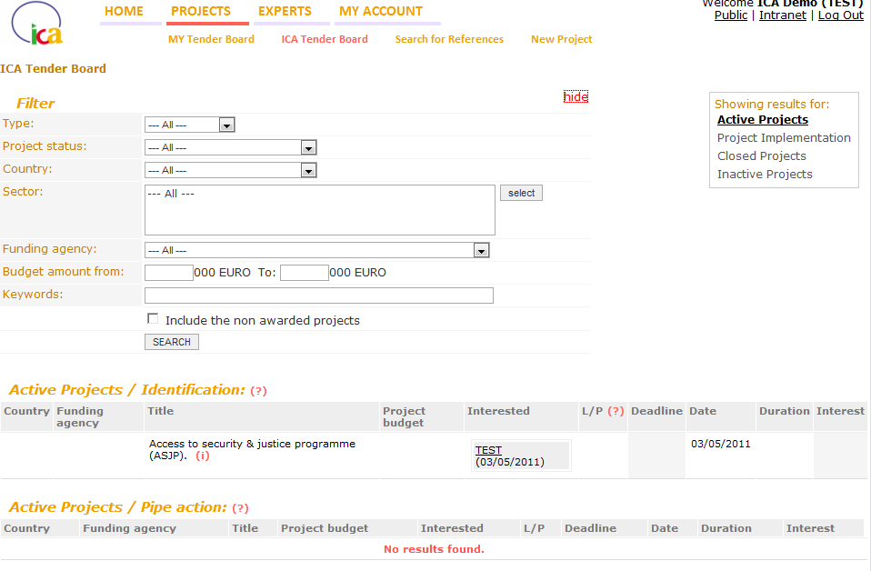

**3. Search for references**

The “search for references” section conducts **default search within your own companies’ references**. To extend your search, tick the box called “**Search in all ICA members’ references**”.

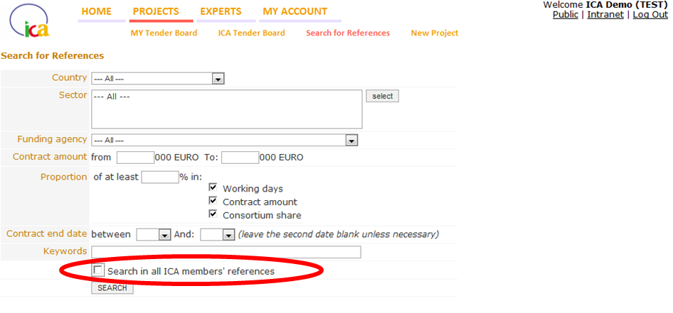

This section of the ICANET may particularly be of use for tenders, if you are looking for the most suitable consortium partners to work with.

Each reference contains the members’ most appropriate contact details, enabling companies to get in touch with each other if interested / in need of certain references.

**4. New Project**

The “New Project” section is where you can **create / input a new project** **manually** (i.e. if you don’t download it via the Assortis website) **into your own Tender Board**. Meaning it will then be visible to all other ICA members via the “ICA Tender Board” section.

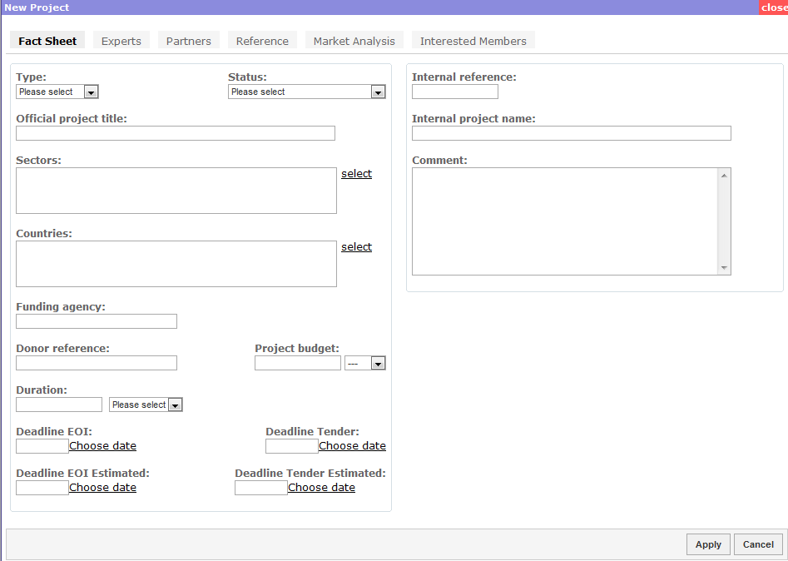

The “New Project” tab will enable you to manage each project individually, including all related tabs – which have already been mentioned above, such as: Fact Sheet, Experts, Partners, Reference, Market Analysis, Interested Members.

* The “EXPERTS” section:

This section enables members to access the **Common ICA expert database**, which is the merge of all members’ individual CVIPs.

Each CV can belong to one or several ICA members (if more than one member possesses the same CV). When members register a CV into their own CVIP (or via the Common expert database – see step 2 here below), it is registered as belonging to the member who registered it. However, as all individual company CVIPs are merged within this Common database, CVs will also partly be visible to other members – but they will not contain any contact details*.*

On this big database members can either:

* **Conduct a CV search on all ICA members’ CVIPs**
* **Register new CVs (onto their own CVIP) and mark them as being their own**

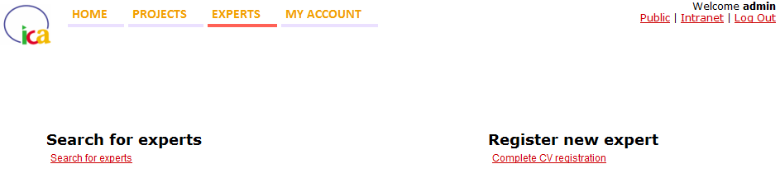

**1. Search for experts**

It is possible to conduct a search for experts by:

* Keywords
* Sector
* Countries
* Funding Agencies
* Other additional search options

The search outputs will show the matching expert CVs according to the query. By clicking on “Preview CV”, ICA **members can see a not fully disclosed version of the expert’s profile** (no contact details, the various experiences are not listed in the correct chronological order, etc) – if and only if the CV doesn’t belong to that member himself.

If interested in a certain CV, members should then **contact the owner company of that particular CV**. Note: there can be multiple owners of one particular CV, in case the same CV has been registered on various individual company CVIPs. This means the interested ICA members can chose whichever owner of the CV they wish to contact, in order to negotiate a full access to the experts’ contact details. This negotiation needs to take place on a case by case basis between ICA members directly – ICA will not get involved on these discussions, which are settled between individual members.

**2. Register new experts**

Before starting their individual CV registration process, it is necessary for members to **check whether a certain CV already exists** in the Common expert database (i.e. in any other members’ individual CVIP): this is the very first step in the registration process. It will **avoid registering the same CV twice** in the Common expert database, and will also **save members valuable registration time** in case a certain CV already exists (in which case members will only need to *update* a CV instead of going through the *entire registration* process).

The system will tell you whether a certain name already exists. If so, it will be necessary to check which version of the CV is the most updated and – when relevant – update the already existing CV in the Common database. The CV will then also be marked as belonging to the member who updated the CV, given that the member also uploads his version of the CV onto the Common database.

If the CV does not yet exist in the Common database, members will need to go through the **registration process** for new CVs, by simply following the indicated steps.